Intervention Tables & HPT Models Used
Table 4
Areas of Opportunity, Interventions, Benefits, & Limitations
Barriers - Why Professionals in Their 30s May Be Leaving
Areas of Opportunity | Suggested Interventions | Impact Rating  1 (low impact)  to  5 (high impact) | Difficulty Rating  1 (very easy)  to  5 (very difficult) | Benefits & Limitations
Salary  (too low) | Create a “total rewards package” that includes all benefits and perks and the value of each of those items. Include the value of educational discounts and discounts for other organizational services (parking, daycare, etc.) | 3 | 1 | Benefit: Employees will see the true value of their employment package and how much they may be saving on expenses.  Benefit: Tallying up the value of things already in place is a fairly low-cost exercise.
 | Perform an analysis to determine salary comparison between XYZU and comparable institutions. | 4 | 4 | Benefit: If salaries at XYZ are comparable to other institutions, employees can be shown that XYZ’s salary/reward package is comparable.  Limitation: If XYZ’s salaries/rewards package is lower than comparable institutions, and there is no budget to raise the salary, it could cause further discontent.
 | Provide employees with the opportunity to take advantage of the academic perks. | 5 | 1 | Benefit: Very low cost to the organization.  Benefit: Happy student-employees will naturally serve to market the university to others
 | Consider increasing perks and discounts as a way to raise the total rewards without having to spend additional funds. Evaluate the costs of each against the potential costs of employee attrition. | 4 | 2 | Benefit: discounts for things that are required expenses (daycare, parking, gym membership, etc.) will improve the overall value of employment at the university, and it may be able to offset some of the salary limitations.  Limitation: This still has a potential cost in terms of lost revenue.
Opportunities for Growth/  Training  (not enough) | Baby Boomers will be retiring soon, so take advantage of creating clear growth paths so people know what the next few years may hold for them. | 5 | 5 | Benefit: providing a roadmap for the future will give employees a reason to stay committed to the organization.  Limitation: Baby Boomers may feel they are being “pushed out” of the organization by younger employees.
 | Create a mentoring program to help younger employees gain tribal knowledge from older employees (perhaps across departments). | 3 | 4 | Benefit: If the program is done across departments, not only will it provide learning opportunities, it will also help connect separate groups of the organization and give employees a chance to see what other departments have to offer.  Limitation: Engagement may be high at first and then could decline.  Limitation: Requires time, resources, and commitment from mentors.
 | Inform employees of training opportunities that currently exist. | 4 | 5 | Benefit: Cost effective way to increase utilization of pre-existing training opportunities would reduce the need to create new training programs.
 | Determine if training needs are widespread or localized to specific departments and/or job description. | 4 | 4 | Benefit: Training could be created on a targeted basis to fit specific needs as opposed to generic training for all employees.  Limitation: Would require conducting needs assessments across multiple departments.
 | Encourage supervisors to allow training release from typical duties. | 5 | 4 | Benefit: Would show employees a commitment to the value of training and costs very little.
 | Encourage training programs to survey attendees about the applicability of the trainings. | 3 | 5 | Benefit: Making tweaks to existing training based on participant feedback would be less expensive than creating new content from scratch.  Limitation: Surveys may not give an accurate picture of exactly whether or not a training is impacting employee behavior and performance.

Facilitators - Why Professionals in Their 30s are Staying
Areas of Opportunity | Suggested Interventions | Impact Rating  1 (low impact)  to  5 (high impact) | Difficulty Rating  1 (very easy)  to  5 (very difficult) | Benefits & Limitations
Meaningful Work (people love this aspect of their jobs!) | Use social media to show employees their positive impact on students.  Encourage employees to connect with other departments. | 5 | 1 | Benefit: Leveraging the low-cost tool of social media may help employees understand their larger impact, even if they themselves can’t see the direct impact (i.e. folks who work at the gym might not see how the stress relief of exercise helps students’ success, but it does.)  Benefit: Students may feel more connected to XYZU and its entire workforce and it could improve student satisfaction.  Limitations: Employees need to be engaged in social media themselves for this intervention to be effective.
 | Promote social connections amongst employees. | 5 | 1 | Benefit: Much of the data points to employees feeling connected to their team, and this being a big reason they love/want-to-stay at their job; it feels like a family to them. Promoting the opportunity to strengthen connections with coworkers will increase happiness overall.
Work-life Balance (great in some departments) | Audit work-life balance practices within departments. | 5 | 3 | Benefit: Encouraging a better work-life balance can help employees manage stress better.  Benefit: Departments with better work-life balance practices employees can learn and benefit from those without those practices.  Limitation: Not all departments have the same working conditions and needs, and not all can modify their current situations. Therefore, it may be difficult to create real change.

Table 6
Intervention Recommendations
Intervention | Scoring | Reasoning | Potential ROI | Alignment to Stated Business Objectives
Use social media to show employees their positive impact on students | High Impact/ Low Difficulty | Many employees indicated that having meaningful work was very important to them. Social media can highlight to employees how they positively affect others. | High | Aligned Objective:  - Provide an impactful educational experience.  - Ensure that staff understand their responsibilities in facilitating student success.
Promote social connections amongst employees | High Impact/ Low Difficulty | Increasing cohesiveness among coworkers will increase teamwork and reinforce the cultural values of XYZU. | High | Aligned Objective:  - Provide an impactful educational experience.  - Ensure that staff understand their responsibilities in facilitating student success.  - Break down silos.
Market the academic perks of working at XYZU | High Impact/ Low Difficulty | These perks are already available to the employees. Employees can feel they are saving money on education expenses by working for XYZU and feel more a part of the XYZU community. | High | Aligned Objective:  - Invest in staff.  - Provide an impactful educational experience.  - Support highly qualified and trained staff.
Create a “total rewards package” | Medium Impact/ Low Difficulty | Show employees they receive compensation that goes beyond their salary. | High | Aligned Objective:  - Invest in staff.  - Allocate resources strategically to promote innovation.
Increase perks | High Impact/ Low Difficulty | If salaries can’t be increased, then additional perks could offset a lower salary. However, budgetary restraints may prevent implementation, therefore it receives a Medium rating. | Medium/ High – if budget allows | Aligned Objective:  - Invest in staff.  - Allocate resources strategically to promote innovation.
Audit work-life balance practices within departments | High Impact/ Medium Difficulty | While some employees were very satisfied with their work-life balance, other employees were not. Finding if the unsatisfied employees are localized to certain departments could help address the problem and increase retention. | Medium/High | Aligned Business Goals:  - Use data to inform decisions.  - Simplify policies.
Allowing employees time for training | High Impact/ Medium Difficulty | This is an easy intervention to implement and will facilitate all the other training suggestions. | Medium/ High | Aligned Objective:  - Support highly qualified and trained staff.  - Invest in staff.
Create a career growth path | High Impact/ High Difficulty | Showing employees that they have a future at XYZU could help in retention. | Medium | Aligned Objective:  - Build infrastructure for growth and research.  - Invest in staff.
Inform employees of current training opportunities | High Impact/ High Difficulty | Inform employees of training currently available. | Medium | Aligned Objective:  - Support highly qualified and trained staff.  - Invest in staff.

Determine training needs by department for consistency | High Impact/ High Difficulty | Highly labor intensive and could return very limited results. | Low | Aligned Objective:  - Support highly qualified and trained staff.  - Invest in staff.  - Use data to inform decisions.  - Simplify policies
Create a mentoring program | Medium Impact/ Medium Difficulty | Although a mentoring program could help employees in their 30s create a career path, it would consume take a large time commitment from both the mentor and the mentee. In small departments that time commitment could significantly reduce the work that is done. | Low | Aligned Objective:  - Support highly qualified and trained staff.  - Invest in staff.
Perform a salary comparison between XYZU and comparable institutions to determine if the salaries between the two organizations are similar | Medium Impact/ Medium Difficulty | Could take a lot of resources. If the salary at XYZU is significantly lower than industry standards, and salaries can not be raised, it could create a barrier to employee retention | Not Recommended | Aligned Objective:  - Invest in staff.
Create training surveys to survey attendees about the applicability of the trainings. | Medium Impact/ High Difficulty | Uses a lot of resources for very little impact. | Not Recommended | Aligned Objective:  - Support highly qualified and trained staff.

Figure 2
Kaufman’s Organizational Elements Model (OEM)
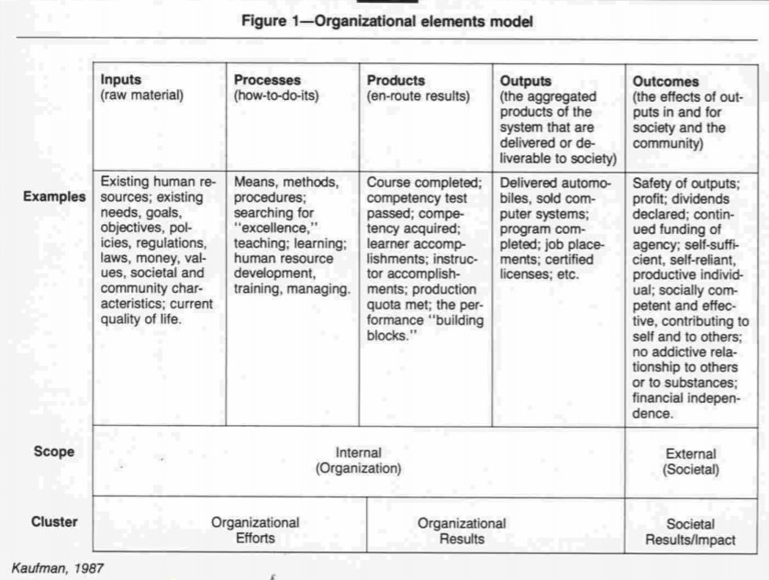
Kaufman’s OEM (1973) (as cited in Kaufman, 1988, Figure 1, p. 81).
Figure 3
Harless’ Front End Analysis
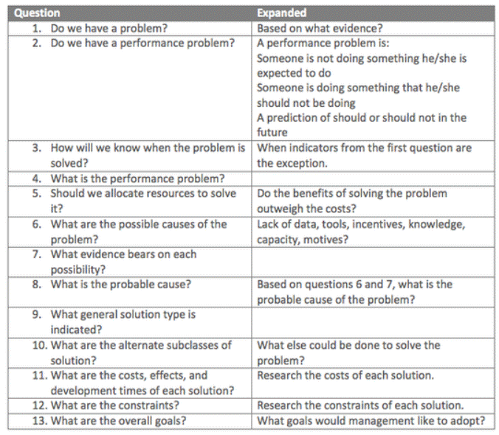
(Harless, 1973)

